**Kiran Fatima (23-SE-05)  
WE Lab report # 4**

**LAB EXERCISE 1**

**Code:**

<!DOCTYPE html>

<html lang="en">

<head>

  <meta charset="UTF-8">

  <meta name="viewport" content="width=device-width, initial-scale=1.0">

  <title>Z-Index Hover Example</title>

  <style>

    .box {

      width: 150px;

      height: 150px;

      position: absolute;

      transition: all 0.3s ease;

      cursor: pointer;

      border-radius: 10px;

    }

    .box1 {

      background: lightcoral;

      top: 50px;

      left: 50px;

      z-index: 1;

    }

    .box2 {

      background: lightseagreen;

      top: 100px;

      left: 100px;

      z-index: 2;

    }

    .box3 {

      background: lightblue;

      top: 150px;

      left: 150px;

      z-index: 3;

    }

    /* 👇 When you hover, increase z-index to bring it forward */

    .box:hover {

      z-index: 999;

    }

  </style>

</head>

<body>

  <div class="box box1"></div>

  <div class="box box2"></div>

  <div class="box box3"></div>

</body>

</html>

**Output:**

Normal: hovering the 2nd box hovering the 1st box

**LAB EXERCISE 2**

**Code:**<!DOCTYPE html>

<html lang="en">

<head>

    <meta charset="UTF-8">

    <meta name="viewport" content="width=device-width, initial-scale=1.0">

    <title>Exercise</title>

</head>

<style>

    body{

        background-color: #000;

    }

    h1{

        color: #fff;

        text-align: center;

        text-transform: uppercase;

        font-family: Impact, 'Arial Narrow Bold', sans-serif, sans-serif;

        font-weight: 200;

        font-size: 2.6rem;

    }

    .container{

        display: flex;

        justify-content: space-evenly;

    }

    .img-flex{

        width: 22%;

        height: 65vh;

        transition: transform 0.3s ease;

    }

    .img-flex:hover{

        transform: scale(1.05);

    }

    .img-flex img{

        object-fit: cover;

        width: 100%;

        height: 100%;

        border-radius: 20px;

    }

</style>

<body>

    <h1>Places to visit</h1>

    <div class="container">

        <div class="img-flex">

            <img src="images/countryside england.jpg" alt="England">

        </div>

        <div class="img-flex">

            <img src="images/Jasper, AB, Canada.jpg" alt="Canada">

        </div>

        <div class="img-flex">

            <img src="images/Qatar.jpg" alt="Qatar">

        </div>

        <div class="img-flex">

            <img src="images/Vietnam.jpg" alt="vietnam">

        </div>

    </div>

</body>

</html>

**Output:**

After hovering the third image ->

**LAB TASK:**

**Code:**

<!DOCTYPE html>

<html lang="en">

<head>

    <meta charset="UTF-8">

    <meta name="viewport" content="width=device-width, initial-scale=1.0">

    <link rel="stylesheet" href="https://cdnjs.cloudflare.com/ajax/libs/font-awesome/7.0.1/css/all.min.css" integrity="sha512-2SwdPD6INVrV/lHTZbO2nodKhrnDdJK9/kg2XD1r9uGqPo1cUbujc+IYdlYdEErWNu69gVcYgdxlmVmzTWnetw==" crossorigin="anonymous" referrerpolicy="no-referrer" />

    <title>Task | WE lab 4</title>

</head>

<style>

    *{

    margin: 0;

    padding: 0;

    box-sizing: border-box;

}

nav{

    width: 100vw;

    background-color: #670160;

}

nav ul{

    width: 100%;

    height: 100%;

    display: flex;

    list-style: none;

    padding: 0 20px;

}

ul li{

    padding: 25px 15px;

}

ul li:hover{

    background-color: #fff;

    cursor: pointer;

    a{

        color: #670160;

    }

}

ul li a{

    font-size: 1.2rem;

    color: #fff;

    text-decoration: none;

}

.bg-div{

    background-image: url(images/bg.jpg);

    background-position: center;

    width: 100%;

    height: 60vh;

}

.table-div{

    width: 100%;

    padding: 40px;

}

table, th, td {

    border:1px solid black;

    border-collapse: collapse;

    text-align: left;

}

th{

    background-color: #ecc0e9;

}

td, th{

    padding: 5px;

}

@media (max-width:786px){

    nav ul {

        flex-direction: column;

    }

}

</style>

<body>

    <nav>

        <ul>

            <li><a href="#"><i class="fa-solid fa-house"></i> Home</a></li>

            <li><a href="#"><i class="fa-solid fa-magnifying-glass"></i> Search</a></li>

            <li><a href="#"><i class="fa-solid fa-phone"></i> Contact</a></li>

            <li><a href="#"><i class="fa-solid fa-user"></i> Login</a></li>

        </ul>

    </nav>

    <div class="bg-div"></div>

    <div class="table-div">

        <table style="width:100%">

            <tr>

                <th></th>

                <th>Name</th>

                <th>Age</th>

                <th>Telephone</th>

                <th>Roll No.</th>

                <th>Subjects</th>

                <th>Address</th>

            </tr>

            <tr>

                <th>Student 1</th>

                <td>Ahmed Ali</td>

                <td>20</td>

                <td>123 456 789</td>

                <td>12-SE-150</td>

                <td>Web dev</td>

                <td>Taxila</td>

            </tr>

            <tr>

                <th>Student 2</th>

                <td>Khizra Hashmi</td>

                <td>21</td>

                <td>234 535 246</td>

                <td>21-SE-152</td>

                <td>SE</td>

                <td>Rawalpindi</td>

            </tr>

        </table>

    </div>

</body>

</html>

**Output:**

Normal view:

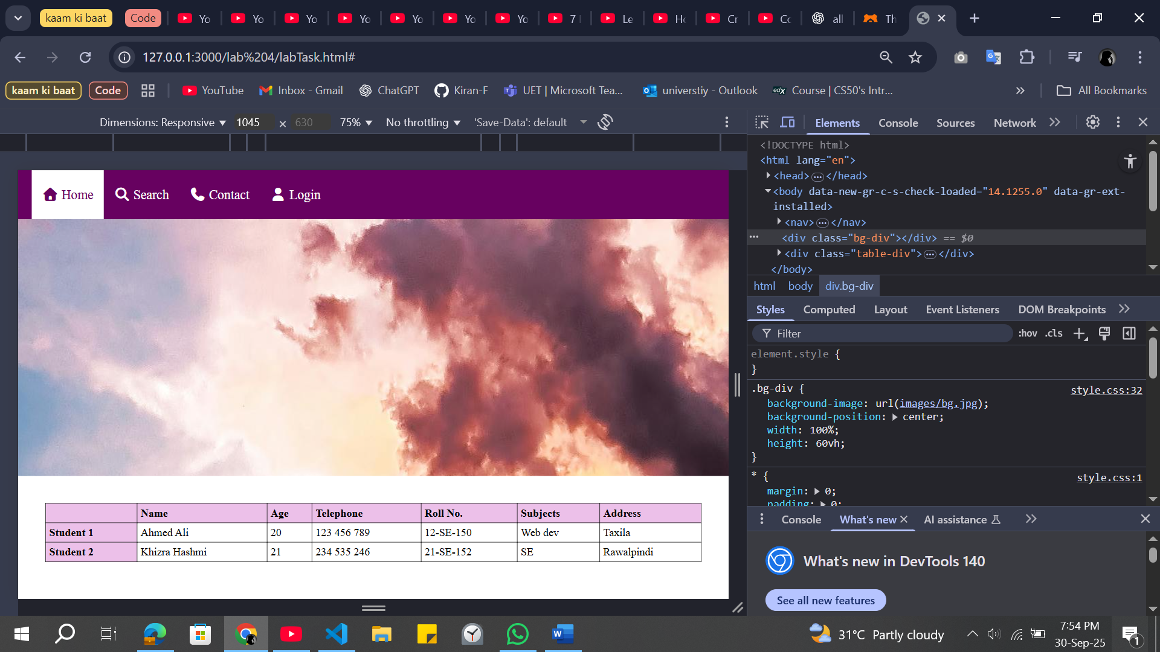

View under 786px view port width:

